1.2 – Algorithms as a technology

keywords:
Limited resources, memory usage, merge sorting, insertion sorting, technology,
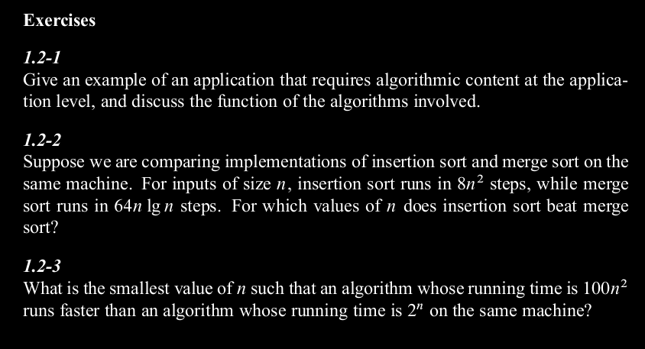
1. Maps are an example. A map portrays the location of the user and can be asked to draw a path to another place, the way that is chosen is by using algorithms. The factors it takes into account are varied, like: available shortcuts, time of the day, traffic, events in the area.
2.

